02.06.20 updated 31.07.20
Booking your lesson
Thank you for your support during lock down, we are so pleased to be able to welcome you back (although things will feel little different to start with)
The office is still closed so we have set up PayPal invoicing for your pre arranged lessons via email with Chris. You have a window of 15 minutes to pay for your booking or unfortunately you will have to start the process again. This allows us to book the instructor’s time in the most efficient way for them and for us.
Cancellation policy
We will now require 3 working days, this is simply because we are working on a VERY tight budget and trying to keep the business afloat through this turbulent time. Any less than 3 days does not allow us time to cover the instructors hourly freelance rate and will then push us into running at a loss which is not good working practice and would force us to close again until most recent restrictions are lifted.
Before you arrive
You will need to send conformation that you understand this document and will adhere to the guidelines we have put in place to keep both rider, spectator , instructor and staff safe at all times. You will be sent a video outlining how to wait and watch your lessons safely. You will need to provide all of your own PPE and ideally have your own riding safety equipment, this includes your own hat that is up to current standards and professionally fitted ( please do not buy 2nd hand or cheaply off the internet as you will be turned away from your lesson at your own cost ) Your hat is the most important piece of riding safety equipment that you can invest in it and it cannot be bought with no human input off the internet- it is dangerous to wear ill-fitting unsafe equipment in a high risk sport. If you are hiring our hat you are restricted to 4 uses then will be asked to get your own. If you are using our hat you will need to measure your head first so that your hat can be arranged for you before your lesson ( ideally 72hrs before the lesson) you will be required to wear a face mask as social distancing is not able while we fit your hat. You will also need the correct footwear, wellington boots are fine to start out with, riding gloves with plastic PPE gloves are compulsory over the top . All of these can be purchased from Widmer feeds and a discount is offered on hats. Fittings are by appointment only through Alice , please contact her via alice@widmer.co.uk We will need an up to date registration form that has been sent to you via email. If you or a member of your house hold is presenting Covid 19 symptoms please follow government guidelines and do not come to the yard for at least 14 days. Please dress according to the weather as ALL lessons will be outside which follows government guidelines. If it is wet, wear a non-flappy jacket without a hood, if it’s hot you will still need to wear a t-shirt that covers your shoulders and the top part of your arm, ideally long sleeve.
When you arrive
Your lesson date and time will have be confirmed via email and or through you payment via PayPal. Please arrive 10 mins before your lesson. We have sent you a video which shows you where to wait for your lesson. Jameys lessons will be in the outdoor competition arena opposite the car park. Claire and Ritas lessons will be in the outdoor rubber arena using the end closest to the carpark. If you are late for your lesson you will be turned away and lose the cost of your pre paid lesson. You may be required to collect your horse from its allocated stable but your instructor will advise you of this. Only one person is allowed to accompany you to your lesson. They can view your lesson from the car park or the allocated viewing arenas always adhering to the 2 meter social distancing guidelines at all times. You are required to sanitise your hands before entering and leaving the arenas, there will be a station for this by the entrance of the school. Please be aware that there are no public toilets .
What we are doing
We have appropriate risk assessments in place which keeps us and you safe . Instructors and team have completed online Covid 19 courses. They have made themselves aware of the changes to first aid which includes the removal of any mouth to mouth resuscitation. They will disinfect reins, stirrup leathers and saddles between riders. They will disinfect gate closing and opening fittings. They will sanatize hats between use and will wear facemasks when fitting hats . They will tailor lessons to competence and ability and will not provide jumping lessons to help keep the pressure off the NHS. They will adhere to the 2 meter distancing guidelines but may on occasion need to work in closer proximity but will have full PPE. They will do a visual demonstration on stirrup and girth adjusting. We are keeping up to date with the government and our governing bodies guidelines.
If you are unwell
Please follow the government guidelines
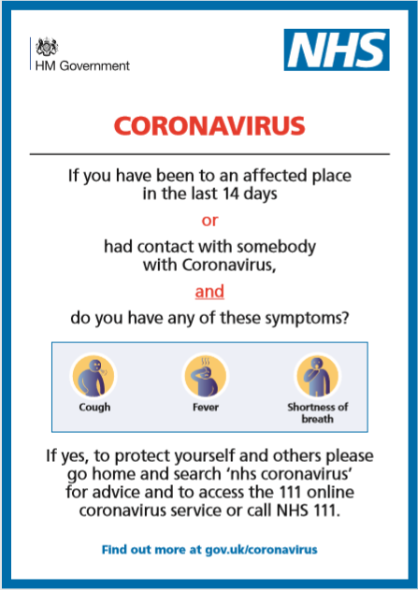
I have read all of the above information and understand it. I will cancel my lesson if I show symptoms of the coronavirus or have had contact with somebody with the virus.
Name :
Riders name if different :
Date :

